Experiment No. 2

Aim: Implement case study on building Data warehouse/Data Mart, write Detailed Problem statement and design dimensional modelling (creation of star and snowflake schema)

Theory:
Star Schema:
A star schema is a widely used data modelling technique in the field of data warehousing and business intelligence. It structures data in a way that simplifies querying and reporting for analytical purposes. The term "star schema" derives from the resemblance of its visual representation to a star, where a central fact table is connected to multiple dimension tables radiating outwards like star points. Here is an overview of the key aspects of a star schema:

1. Fact Table:
- At the centre of the star schema is the fact table, which holds quantitative and numeric data that represent business events or transactions, such as sales, orders, or revenue.
- Each row in the fact table corresponds to a specific event or transaction and contains measures or metrics to be analysed, such as sales amount or profit.

2. Dimension Tables:
- Surrounding the fact table are dimension tables, which contain descriptive attributes that provide context to the measures in the fact table.
- Dimension tables represent the various ways data can be sliced, diced, or analyzed. Examples include time, geography, products, customers, and more.
- Each dimension table typically contains a primary key that establishes a relationship with the fact table.

3. Relationships:
- The fact table is connected to each dimension table through foreign keys. These keys create relationships that allow analysts to correlate facts with relevant dimensions.
- Relationships enable data users to answer questions like "What were the sales in a specific region during a particular time period?"

4. Benefits:
- Simplified Queries: Star schema simplifies querying by reducing the number of joins required for analysis. This enhances query performance and response time.
- Improved Understandability: The structure's clarity makes it easy for analysts to understand and navigate data relationships, facilitating effective analysis.
5. Drawbacks:
- Data Redundancy: Since dimension attributes are repeated in each row of the dimension table, there can be some redundancy in storage.
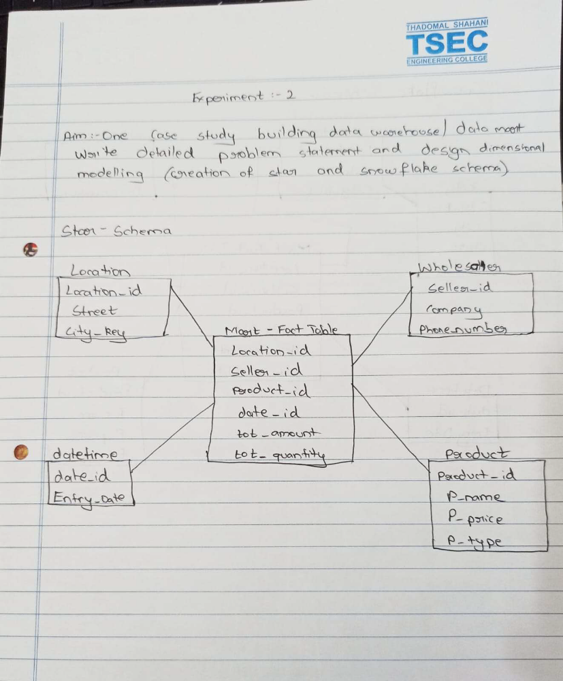
Snowflake schema:
The Snowflake Schema is a normalized form of a multidimensional data model used in data warehousing and OLAP systems. It extends the concepts of the star schema and aims to reduce redundancy while enhancing data integrity and flexibility. The name "snowflake" comes from the shape of the schema when visualized, resembling a snowflake with its branches.

Key characteristics of the Snowflake Schema:

1. Normalization: Unlike the star schema, which denormalizes data into a single fact table and dimension tables, the snowflake schema further normalizes dimension tables. This means breaking down dimensions into sub-dimensions and related tables, reducing data redundancy.

2. Hierarchical Structure: The schema's structure resembles a hierarchy. Dimension tables are broken down into sub-dimensions and related attributes, forming a branching structure similar to the branches of a snowflake.

3. Reduced Redundancy: By normalizing data, the snowflake schema minimizes data duplication. This approach optimizes storage and maintains data consistency, reducing the chances of anomalies and update anomalies that can occur with redundant data.

4. Data Integrity: The normalized structure enhances data integrity by eliminating anomalies and inconsistencies associated with redundant data. Updates or modifications are made in fewer places, ensuring accuracy and reliability.

5. Flexibility: Snowflake schema allows for more flexible changes to attributes and relationships without impacting other parts of the schema. This makes it easier to adapt to evolving business needs.

6. Complex Queries: While snowflake schema promotes data integrity, it can lead to more complex query structures due to the need for multiple joins between related tables. This can affect query performance compared to simpler schemas like the star schema.

7. Space Efficiency: The normalized structure can lead to improved storage efficiency, especially for large datasets with repetitive attribute values.

8. Maintenance: Snowflake schema might require more complex maintenance due to the larger number of tables and relationships. However, modern database management tools have made managing such structures more manageable.
The Snowflake Schema is suitable when data integrity and accuracy are of prime importance, and storage efficiency is a consideration. It is often used in scenarios where frequent updates and changes are required, while maintaining data consistency. While it offers advantages in terms of data normalization and integrity, it is important to consider the trade-offs in query complexity and performance when choosing between different schema designs for a data warehouse or OLAP system.
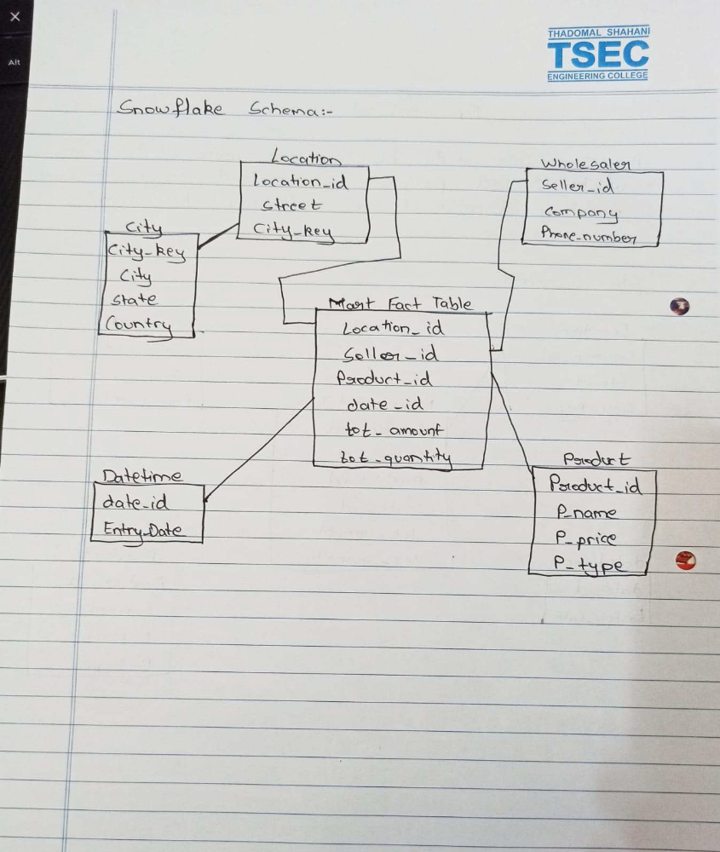
Conclusion:
In conclusion, the Snowflake Schema offers a normalized and hierarchical approach to organizing data in data warehousing and OLAP systems. While enhancing data integrity, minimizing redundancy, and enabling flexibility, it introduces complexities in query structures and maintenance. Organizations must weigh the benefits of improved data consistency against potential trade-offs in query performance when choosing the Snowflake Schema for their data modelling needs.

